Biography of Rabbi Arnold Josiah Ford
By
Rabbi Sholomo Ben Levy

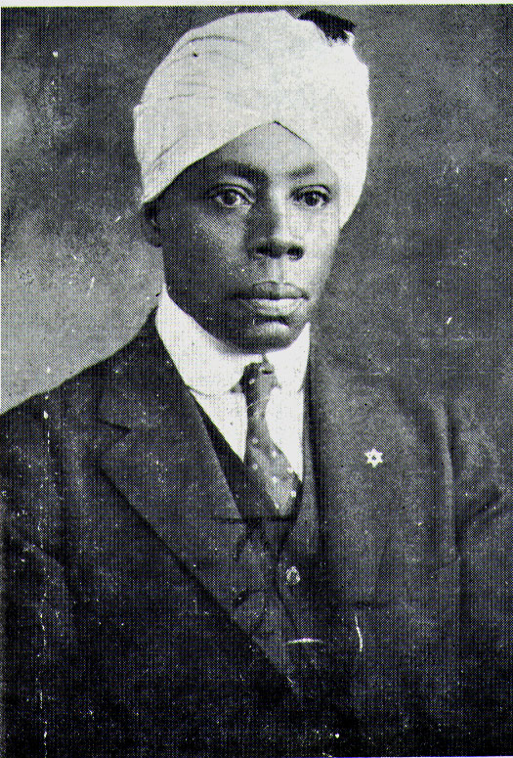

Ford, Arnold Josiah (23 Apr. 1877-16 Sept. 1935), rabbi, black nationalist, and emigrationist, was born in Bridgetown, Barbados, the son of Edward Ford and Elizabeth Augusta Braithwaite. Ford asserted that his father’s ancestry could be traced to the Yoruba tribe of Nigeria and his mother’s to the Mendi tribe of Sierra Leone. According to his family’s oral history, their heritage extended back to one of the priestly families of the ancient Israelites, and in Barbados his family maintained customs and traditions that identified them with Judaism (Kobre, 27). His father was a policeman who also had a reputation as a “fiery preacher’ at the Wesleyan Methodist Church where Arnold was baptized; yet, it is not known if Edward’s teaching espoused traditional Methodist beliefs or if it urged the embrace of Judaism that his son would later advocate.
Ford’s parents intended for him to become a musician. They provided him with private tutors who instructed him in several instruments—particularly the harp, violin, and bass. As a young adult, he studied music theory with Edmestone Barnes and in 1899 joined the musical corps of the British Royal Navy, where he served on the HMS Alert. According to some reports, Ford was stationed on the island of Bermuda, where he secured a position as a clerk at the Court of Federal Assize, and he claimed that before coming to America he was a minister of public works in the Republic of Liberia, where many ex-slaves and early black nationalists settled.
When Ford arrived in Harlem around 1910, he gravitated to its musical centers rather than to political or religious institutions—although within black culture, all three are often interrelated. He was a member of the Clef Club Orchestra, under the direction of James Reese Europe, which first brought jazz to Carnegie Hall in 1912. Other black Jewish musicians, such as Willie “the Lion” Smith, an innovator of stride piano, also congregated at the Clef Club. Shortly after the orchestra’s Carnegie Hall engagement, Ford became the director of the New Amsterdam Musical Association. His interest in mysticism, esoteric knowledge, and secret societies is evidenced by his membership in the Scottish Rite Masons, where he served as Master of the Memmon Lodge. It was during this period of activity in Harlem, he married Olive Nurse, with whom he had two children before they divorced in 1924.
In 1917 Marcus Garvey founded the New York chapter of the Universal Negro Improvement Association [UNIA], and within a few years it had become the largest mass movement in African American history. Arnold Ford became the musical director of the UNIA choir, Samuel Valentine was the president, and Nancy Paris its lead singer. These three became the core of an active group of black Jews within the UNIA who studied Hebrew, religion, and history, and held services at Liberty Hall, the headquarters of the UNIA. As a paid officer, Rabbi Ford, as he was then called, was responsible for orchestrating much of the pageantry of Garvey’s highly attractive ceremonies. Ford and Benjamin E. Burrell composed a song called “Ethiopia,” which speaks of a halcyon past before slavery and stresses pride in African heritage—two themes that were becoming immensely popular. Ford was thus prominently situated among those Muslim and Christian clergy, including George Alexander McGuire, Chaplain-General of the UNIA, who were each trying to influence the religious direction of the organization.
Ford’s contributions to the UNIA, however, were not limited to musical and religious matters. He and E.L. Gaines wrote the handbook of rules and regulation for the paramilitary African Legion (which was modeled after the Zionist Jewish Legion) and developed guidelines for the Black Cross Nurses. He served on committees, spoke at rallies, and was elected one of the delegates representing the 35,000 members of the New York chapter at the First International Convention of Negro Peoples of the World, held in 1920 at Madison Square Garden. There the governing body adopted the red, black, and green flag as its ensign, and Ford’s song “Ethiopia” became the “Universal Ethiopian Anthem,” which the UNIA constitution required be sung at every gathering. During that same year, Ford published the Universal Ethiopian Hymnal. Ford was a proponent of replacing the term “Negro” with the term “Ethiopian,” as a general reference to people of African descent. This allowed the biblical verse “Ethiopia shall soon stretch out her hand to God,” (Psalm 68:3) to be interpreted as applying to their efforts and it became a popular slogan of the organization. At the 1922 convention, Ford opened the proceedings for the session devoted to “The Politics and Future of the West Indian Negro,” and he represented the advocates of Judaism on a five-person ad hoc committee formed to investigate “the Future Religion of the Negro.” Following Garvey’s arrest in 1923, the UNIA loss much of its internal cohesion. Since Ford and his small band of followers were motivated by principals that were independent of Garvey’s charismatic appeal, they were repeatedly approached by government agents and asked to testify against Garvey at trial, which they refused to do. However, in 1925, Ford brought separate law suits against Garvey and the UNIA for failing to pay him royalties from the sale of recordings and sheet music, and in 1926 the judge ruled in Ford’s favor. No longer musical director, and despite his personal and business differences with the organization, Rabbi Ford maintained a connection with the UNIA and was invited to give the invocation at the annual convention in 1926.
Several black religious leaders were experimenting with Judaism in various degrees between the two world wars. Rabbi Ford formed intermittent partnerships with some of these leaders. He and Valentine started a short lived congregation called Beth B’nai Israel. Ford then worked with Mordecai Herman and the Moorish Zionist Temple, until they had an altercation over theological and financial issues. Finally, he established Beth B’nai Abraham in Harlem in 1924. A Jewish scholar who visited the congregation described their services as “a mixture of Reform and Orthodox Judaism, but when they practice the old customs they are seriously orthodox” (Kobre, 25). Harlem chronicler James VanDerZee photographed the congregation with the Star of David and bold Hebrew lettering identifying their presence on 135th Street and showing Rabbi Ford standing in front of the synagogue with his arms around his string bass, and with members of his choir at his side, the women wearing the black dresses and long white head coverings that became their distinctive habit and the men in white turbans.
In 1928, Rabbi Ford created a business adjunct to the congregation called the B’nai Abraham Progressive Corporation. Reminiscent of many of Garvey’s ventures, this corporation issued one hundred shares of stock and purchased two buildings from which it operated a religious and vocational school in one and leased apartments in the other. However, resources dwindled as the Depression became more pronounced, and the corporation went bankrupt in 1930. Once again it seemed that Ford’s dream of building a black community with cultural integrity, economic viability, and political virility was dashed, but out of the ashes of this disappointment he mustered the resolve to make a final attempt in Ethiopia. The Ethiopian government had been encouraging black people with skills and education to immigrate to Ethiopia for almost a decade, and Ford knew that there were over 40,000 indigenous black Jews already in Ethiopia (who called themselves Beta Israel, but who were commonly referred to as Falasha). The announced coronation of Haile Selassie in 1930 as the first black ruler of an African nation in modern times raised the hopes of black people all over the world and led Ford to believe that the timing of his Ethiopian colony was providential.
Ford arrived in Ethiopia with a small musical contingent in time to perform during the coronation festivities. They then sustained themselves in Addis Abba by performing at local hotels and relying on assistance from supporters in the United Sates who were members of the Aurienoth Club, a civic group of black Jews and black nationalists, and members of the Commandment Keepers Congregation, led by Rabbi W. A. Matthew, Ford’s most loyal protégé. Mignon Innis arrived with a second delegation in 1931 to work as Ford’s private secretary. She soon became Ford’s wife, and they had two children in Ethiopia. Mrs. Ford established a school for boys and girls that specialized in English and music. Ford managed to secure eight hundred acres of land on which to begin his colony and approximately one hundred individuals came to help him develop it. Unbeknownst to Ford, the U.S. State Department monitored Ford’s efforts with irrational alarm, dispatching reports with such headings as “American Negroes in Ethiopia—Inspiration Back of Their Coming Here—‘Rabbi’ Josiah A. Ford,” and instituting discriminatory policies to curtail the travel of black citizens to Ethiopia.
Ford had no intention of leaving Ethiopia, so he drew up a certificate of ordination (shmecha) for Rabbi Matthew that was sanctioned by the Ethiopian government in the hope that this document would give Matthew the necessary credentials to continue the work that Ford had begun in the United States. By 1935 the black Jewish experiment with Ethiopian Zionism was on the verge of collapse. Those who did not leave because of the hard agricultural work, joined the stampede of foreign nationals who sensed that war with Italy was imminent and defeat for Ethiopia certain. Ford died in September, it was said, of exhaustion and heartbreak, a few weeks before the Italian invasion. Ford had been the most important catalyst for the spread of Judaism among African Americans. Through his successors, communities of black Jews emerged and survived in several American cities.
Further Reading
King, Kenneth J. “ Some Notes on Arnold J. Ford and New World Black Attitudes to Ethiopia,” in Black Apostles: Afro-American Clergy Confront the Twentieth Century, Randall Burkett and Richard Newman, eds. (1978).
Kobre, Sidney. “Rabbi Ford,” The Reflex 4, no. 1 (1929): 25-29.
Scott, William R. “Rabbi Arnold Ford’s Back-to-Ethiopia Movement: A Study of Black Emigration, 1930-1935,” Pan-African Journal 8, no. 2 (1975):191-201.

* No part of these essays may be used without the author’s permission.

Biography of Rabbi W.A. Matthew
By
Rabbi Sholomo Ben Levy

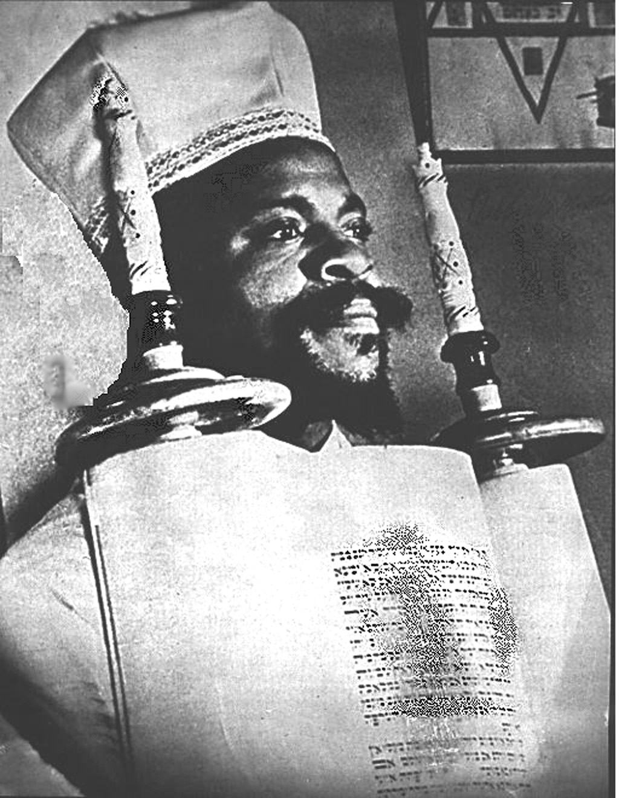
Chief Rabbi W.A. Matthew
Matthew, Wentworth Arthur (23 June 1892-3 Dec. 1973), rabbi and educator, is believed to have been born in St. Marys, St. Kitts, in the British West Indies, the son of Joseph Matthew and Frances M. Cornelius. Matthew gave seemingly contradictory accounts of his ancestry that put his place of birth in such places as Ethiopia, Ghana, and Lagos, Nigeria. Some of those lingering discrepancies were partially clarified when Matthew explained that his father, a cobbler from Lagos, was the son of an Ethiopian Jew, a cantor who sang their traditional liturgies near the ancient Ethiopian capital of Gondar. Matthew’s father then married a Christian woman in Lagos and they gave their son, Wentworth, the Hebrew name Yoseh ben Moshe ben Yehuda, also given as Moshea Ben David. His father died when he was a small boy and his mother took him to live in St. Kitts, where she had relatives who had been slaves on the island (Ottley, 143).
In 1913 Matthew immigrated to New York City, where he worked as a carpenter and engaged in prize fighting, though he was just a scrappy five feet four inches tall. He reportedly studied at Christian and Jewish schools, including the Hayden Theological Seminary, the Rose of Sharon Theological Seminary (both now defunct), Hebrew Union College in Cincinnati, and even the University of Berlin, but there is no independent evidence to corroborate his attendance at these institutions. In 1916 Matthew married Florence Docher Liburd, a native of Fountaine, Nevis, with whom he would have four children. During the First World War, Matthew was one of many street exhorters who used a ladder for a pulpit and Harlem’s bustling sidewalks as temporary pews for interested pedestrians. By 1919 enough people were drawn to his evolving theology of Judaism and black nationalism that he was able to found “The Commandments Keepers Church of the living God The pillar and ground of the truth And the faith of Jesus Christ.” He attempted to appeal to a largely Christian audience by pointing out that observance of the Old Testament commandments was the faith of Jesus; however, it became apparent that visitors often missed this point and assumed that any reference to Jesus implied a belief in Jesus. To avoid this confusion with Christianity, Matthew ceased to use the title Bishop and removed all references to Jesus from his signs and later from their papers of incorporation.
The transition from a church-based organization holding Jewish beliefs to a functioning synagogue that embraced most of the tenets of mainstream Orthodox Judaism was accomplished by Matthew’s association with Rabbi Arnold Ford. Ford was a luminary in the Universal Negro Improvement Association, a black nationalist organization led by Marcus Garvey. Rabbi Ford offered Hebrew lessons and religious instruction to a number of laypeople and clergy in the Harlem area. Ford worked with both Matthew’s Commandments Keepers Congregation and the Moorish Zionist Congregation led by Mordecai Herman in the 1920s before starting his own congregation, Beth B’nai Abraham. In 1931, after Ford emigrated to Ethiopia he sent a letter to Matthew granting him “full authority to represent Us in America” and furnishing him with a Shmecah, a certificate of rabbinic ordination (Ford to Matthew, 5 June 1931). Throughout the rest of his career, Matthew would claim that he and his followers were Ethiopian Hebrews, because in their lexicon Ethiopian was preferred over the term Negro, which they abhorred, and because his authority derived from their chief rabbi in Ethiopia.
As an adjunct to his congregation, Matthew created a Masonic lodge called The Royal Order of Aethiopian Hebrews the Sons and Daughters of Culture. He became a U.S. citizen in 1924 and the following year created the Ethiopian Hebrew Rabbinical College for the training of other black rabbis. Women often served as officers and board members of the congregation, though they could not become rabbis. In the lodge there were no gender restrictions and woman took courses and even taught in the school. Religion, history, and cultural anthropology, presented from a particular Afrocentric perspective, were of immense interest to Matthew’s followers and pervaded all of his teaching. The lodge functioned as a secret society where the initiated explored a branch of Jewish mysticism called kabballah, and the school sought to present a systematic understanding of the practice of Judaism to those who initially adopted the religion solely as an ethnic identity. While the black press accepted the validity of the black Jews in their midst, the white Jewish press was divided; some reporters accepted them as odd and considered their soulful expressions exotic, most challenged Matthew’s identification with Judaism, and a few ridiculed “King Solomon’s black children” and mocked Matthew’s efforts to “teach young pickaninnies Hebrew” (Newsweek, 13 Sept. 1934).
Matthew traveled frequently around the country, establishing tenuous ties with black congregations interested in his doctrine. He insisted that the original Jews were black and that white Jews were either the product of centuries of intermarriage with Europeans or the descendents of Jacob’s brother Esau, whom the bible describes as having a “red” countenance. Matthew argued that the suffering of black people was in large measure God’s punishment for having violated the commandments. When black people “returned” to Judaism, he believed, their curse would be lifted and the biblical prophecies of redemption would be fulfilled. Most of the black Jewish congregations that sprung up in the post Depression era trace their origin to Matthew or William Crowdy, a nineteenth century minister whose followers also embraced some aspects of Judaism, but unlike Matthew’s followers, never abandoned New Testament theology. When Matthew spoke of the size of his following, he appeared to count many of these loose affiliations and he also included those who expressed an interest in Judaism, not just those who adhered to his strict doctrine of Sabbath worship, kosher food, bar mitzvahs, circumcision, and observance of all Jewish holidays. The core of his support came from a few small congregations in New York, Chicago, Ohio, and Philadelphia. Many of his students established synagogues in other parts of New York City; often they were short-lived and those that thrived tended to become revivals rather than true extensions of Matthew’s organization.
During the second world war, two of Matthews sons served in the military and the congregation watched with horror as atrocities against Jews were reported. In 1942 Matthew published the Minute Book, a short history of his life’s work, which he described as the “most gigantic struggle of any people for a place under the sun.” Matthew would later publish Malach (Messenger), a community newsletter. Having supported the Zionist cause, the congregation celebrated the creation of the state of Israel in 1948, but by the 1950s their dreams of settling in Africa or Israel had been replaced by a more modest vision of establishing a farming collective on Long Island. The congregation purchased a few parcels of land in North Babylon in Suffolk County, New York, and began building a community that was to consist of a retirement home for the aged, residential dwellings, and small commercial and agricultural industry. Opposition from local residents and insufficient funding prevented the property from being developed into anything more than a summer camp and weekend retreat for members, and the land was lost in the 1960s.
When a new wave of black nationalism swept the country during the civil rights movement, there were brought periods of closer unity between blacks and Jews, but also painful moments of tension in major cities. Matthew enjoyed a close relationship with Adam Clayton Powell Jr. in Harlem, with Percy Sutton, who as Borough President of Manhattan proclaimed a day in Matthew’s honor, and with congressman Charles Rangel, who was a frequent guest at Commandment Keepers. Matthew also became affiliated with Rabbi Irving Block, a young white idealist who had recently graduated from Jewish Theological Seminary and started the Brotherhood Synagogue. Block encouraged Matthew to seek closer ties with the white Jewish community and he urged white Jewish institutions to accept black Jews. Matthew applied for membership in the New York Board of Rabbis and in B’nai B’rith, but was rejected. Publicly they said that Matthew was turned down because he was not ordained by one of their seminaries; privately they questioned whether Matthew and his community were Jewish at all. After reflecting on this incident and its aftermath, Matthew said, “The sad thing about this whole matter is, that after forty or fifty years…they are planning ways of discrediting all that it took us almost two generations to accomplish” (Howard Waitzkin, “Black Judaism in New York,” Harvard Journal of Negro Affairs 1967, 1.3).
In an effort to circumvent Matthew’s leadership of the black Jewish community, a “Committee on Black Jews” was created by the Commission on Synagogue Relations. They in turn sponsored an organization called Hatza’ad Harishon (The First Step), which attempted to bring black people into the Jewish mainstream. Despite their liberal intentions, the project failed because it was unable to navigate the same racial and ritual land mines that Matthew had encountered. Matthew had written that “a majority of the [white] Jews have always been in brotherly sympathy with us and without reservation” (New York Age, 31 May 1958), but because he refused to assimilate completely he met fierce resistance from white Jewish leadership. As he explained,
We’re not trying to lose our identity among the white Jews. When the white Jew comes among us, he’s really at home, we have no prejudice. But when we’re among them they’ll say you’re a good man, you have a white heart. Or they’ll be overly nice. Deep down that sense of superiority-inferiority is still there and no black man can avoid it. (Shapiro, 183)
Before Matthew’s death at the age of eighty-one, he turned the reins of leadership over to a younger generation of his students. Rabbi Levi Ben Levy, who founded Beth Shalom E.H. Congregation and Beth Elohim Hebrew Congregation, engineered the formation of the Israelite Board of Rabbis in 1970 as a representative body for black rabbis, and he transformed Matthew’s Ethiopian Rabbinical College into the Israelite Rabbinical Academy. Rabbi Yehoshua Yahonatan and his wife Leah formed the Israelite Counsel, a civic organization for black Jews. Matthew expected that his grandson, Rabbi David Dore, a graduate of Yeshiva University, would assume leadership of Commandments Keepers Congregation, but as a result of internecine conflict and a painful legal battle, Rabbi Chaim White emerged as the leader of the congregation and continued the traditions of Rabbi Matthew.
Matthew and his cohorts were autodidacts, organic intellectuals, who believed that history and theology held the answers to their racial predicament. Hence, their focus was not on achieving political rights, but rather on discovering their true identities. They held a Darwinian view of politics in which people who do not know their cultural heritage are inevitably exploited by those who do. In this regard, Rabbi Matthew, Noble Drew Ali, and Elijah Mohammad differ in their solutions but agree in their cultural assessment of the overriding problem facing black people.

Further Reading
The largest collection of papers and documents from Matthew and about black Jews is to be found at the Schomburg Center for Research in Black Culture, New York Public Library. Smaller collections are at the American Jewish Archives in Cincinnati.
Brotz, Howard. The Black Jews of Harlem: Negro Nationalism and the Dilemmas of Negro Leadership (1970).
Landing, James E. Black Judaism:Story of an American Movement (2002).
Ottley, Roi. New World A-Coming: Inside Black America (1943).
Shapiro, Deanne Ruth. Double Damnation, Double Salvation: The Source and Varieties of Black Judaism in the United States, M.A. Thesis, Columbia University (1970).

* No part of these essays may be used without the author’s permission.

Biography of Rabbi Yirmeyahu Yisrael
History of Kohol Beth B’nai Yisrael and Bnai Adath Kol Bet Yisrael
By
Rabbi Sholomo Ben Levy

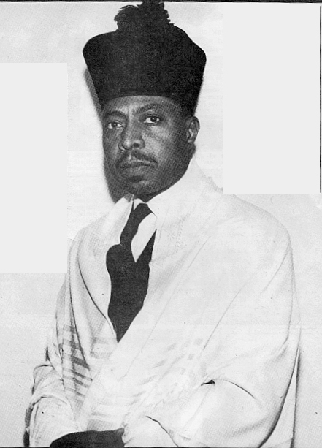
Rabbi Yirmeyahu Yisrael

Rabbi Yirmeyahu Yisrael began life as Julius Wilkins and used the name Wilkins during the early part of his rabbinic career with Kohol Beth B’nai Yisroel and later with B’nai Adath Kol Bet Yisroel. By the 1960s, he used the name Yisrael, which is how he is best remembered. It is believed that his parents migrated from the South, probably from North Carolina, to Harlem, where Rabbi Yisrael grew up between WWI and the Depression. His mother was a member of the Commandment Keepers Ethiopian Hebrew Congregation that was founded by Rabbi W.A. Matthew in 1919 and was then located at 87 West Lenox Avenue. Many of the early members of Commandment Keepers were followers of Marcus Garvey, including Rabbi Matthew’s teacher, Rabbi Arnold J. Ford.

Rabbi Yisrael graduated from the Ethiopian Rabbinical College, a private rabbinic institution founded by Rabbi Matthew in 1925, and was ordained in 1940. According to Rabbi Hailu Paris, Rabbi Yisrael was very intelligent, energetic, and ambitious. Within a few years of his ordination, he felt that he was ready to start his own congregation, one where he could implement changes to the community’s Judaic tradition that would bring its liturgy further inline with those of white Orthodox Jews while maintaining the strongly held belief that the original Jews were black people. For several months individuals met in his home on seventh avenue before acquiring space for their new congregation, Kohol Beth B’nai Yisroel, Inc., in the fall of 1945. Their synagogue was first located above a tailor shop and below a meeting hall for the Universal Negro Improvement Association (UNIA) at 204 Lenox Avenue—just a few blocks from Matthew’s similarly situated congregation. The fact that approximately fifty members of Commandment Keepers eventually left to join Kohol or actively supported it further added to the tension and sense of rivalry that slowly estranged Matthew from his most dynamic student of that period. The following invitation to the dedication ceremonies of Kohol on 25 November 1945 was addressed to the UNIA Division 100 and was found in the UNIA collection at the Schomburg Center for Research in Black Culture.

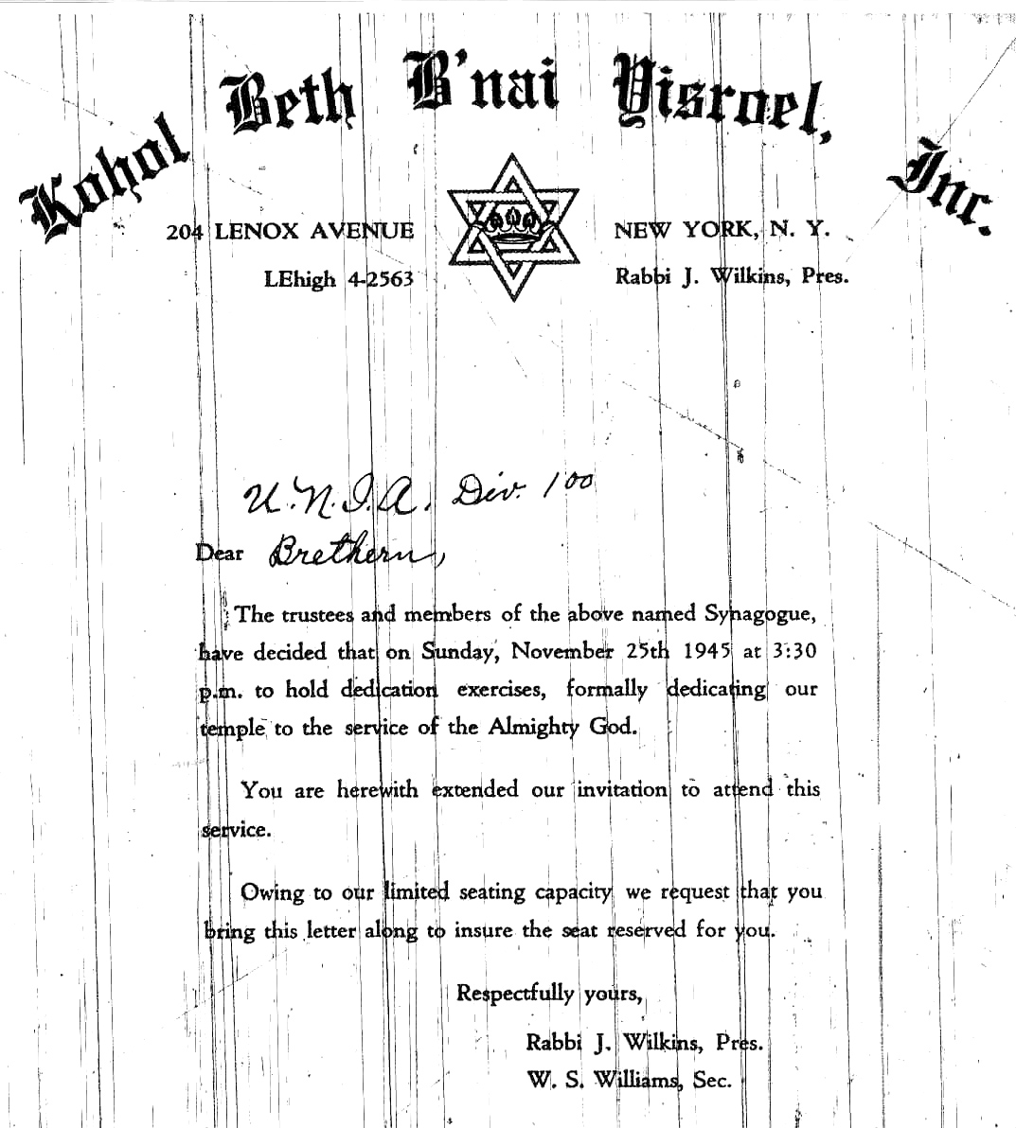

The program for the dedication ceremonies indicates that they opened with Rabbi Ford’s original composition “Sine on Eternal Light,” they then sang Psalm 122. Bro. Philip Evelyn presented the key to the synagogue to Rabbi Wilkins followed by Pslam 84. Other notable features include the singing of “They that trust in the Lord,” “Now Thank We All Our God” and “Glorious Things of Thee are Spoken.” They marched around the synagogue seven times with the Torah which had been donated by Eudora Paris and had a ceremonial lighting of the “Perpetual Light / Nir Tamed.” The prayers that were said included the Kaddish by Rabbi L. Samuels, the Shema, and the evening liturgy. An address was given by Rabbi E.J. McCleod, who would later vie with Yisrael for control of the congregation. It is also significant that the ceremonies included the singing of the national anthems of America and that of Ethiopia.

For almost ten years the new congregation grew steadily but a rift gradually developed between the old guard, best represented by Rabbi McLeod and the new guard, represented by Rabbi Yisrael. The minutes of a meeting that took place on 1 July 1951, which is located in the Kohol Beth B’nai Yisrael Collection SCM95 –27 /MG 575, reveals that a primary area of contention related to the content of their liturgy—particularly concerning songs that were popular in the black Christian traditions of America and the Caribbean and the nationalistic songs composed by Rabbi Ford. Rabbi Wilkins is quoted as referring to the “unfitness for our service of some of the numbers we sing.” It seems that Rabbi Yisrael and a large core of supports were becoming uncomfortable singing songs that were strongly identified with the black Church, even though none of the songs they used referred to Jesus and most were drawn from the Old Testament Bible images that characterize Negro spirituals. It is also likely that many of Rabbi Ford’s nationalistic songs—particularly those that referred to Ethiopia—were becoming passé by the 1950s; even members of the Paris and Piper families who attempted to emigrate to Ethiopia in the 1930s had become somewhat disillusioned. The songs, prayers, and customs that Rabbi Yisrael wanted to replace aspects of the older tradition were often chants, hymns, and practices that were popular in white Orthodox synagogues.
A split occurred shortly before 2 May 1954 because on that date a meeting was called. The minutes from this meeting refer to “cruel actions” taken by Rabbi Wilkins that were “out of place.” It also indicates that Rabbi Wilkins “has discontinued his service as Rabbi; he is demanding $2,000 and 2 Torahs and 50% of the Temple books.” The congregation continued under the leadership of Rabbi McLeod for several more years. In January 1957 overtures were made byRabbi Abel Respes who founded Temple Adat Beyt Moshe in Philadelphia in 1951 (the congregation later moved to Elwood, New Jersey in 1962, chose to live communally, and underwent a formal conversion to Judaism in 1971). Rabbi Respes attempted to get Kohol to pursue new efforts to integrate with white Jews. Rabbi C. Moses, who founded Mt. Horeb congregation in the Bronx 1945, was present at this meeting and was troubled by Rabbi Respes reputation for soliciting white Jews for financial support and Moses expressed grave concerns about how receptive white Jews would be to them. Sister Paris cautioned the group that “white Jewry has controversy within itself;” this remark most likely refers to the deep theological division between the Orthodox, Reform, and Conservative branches of American Judaism. Joining white Jews would require taking sides with one of the main divisions.
Rabbi Yisrael’s second congregation, B’nai Adath Kol Beth Yisroel, was located in Harlem at 4 West 121 Street and was incorporated on 1 May 1954. Mrs. Myrtle Pilgrim was elected Secretary of the congregation and Victor A. George was among the first ten charter members. Unlike Kohol, B’nai Adath would attract newer, younger followers who did not have prior affiliations with older black Jewish congregations. Later in the year, the congregation moved to modest accommodations at 131 Patchen Avenue in Brooklyn. The congregation experienced rapid growth during the 1960s, growing to several hundred members. Many of the new adherents were attracted to Judaism because of the new wave of black consciousness that, like the Garveyment of the 1930s, stressed discovering the true identity of black people. Around the mid 1960s, B’nai Adath took possession of a huge synagogue building at 1006 Green Avenue after the dwindling Orthodox community that built the edifice around the turn of the century could no longer sustain it. With the capacity of seating several hundred worshipers, B’nai Adath became the largest congregation founded by one of Rabbi Matthew’s students.

During the 1970s, B’nai Adath served as the principal meeting place for a group of black rabbis that included Rabbi Yisrael’s peers in Rabbi Woods and Moses, but also a third generation of Rabbi Matthew’s students that included Rabbi Y. Yahonatan (J. Williams), Rabbi Levi Ben Levy (L. McKethan), and Rabbi Paris, who had, in fact, been Bar Mitzvahed by Rabbi Yisrael in 1947. In 1971 this group organized themselves into the Israelite Board of Rabbis (IBR) and in 1973, the same year in which Rabbi Matthew died, the IBR renamed their alma mater, the Ethiopian Hebrew Rabbinical College, to become the Israelite Rabbinical Academy. Rabbi Yisrael was undoubtedly surprised and disappointed when the body elected him to the post of vice president and chose the much younger Rabbi Levy to be their president. Rabbi Levy has recently acquired a large synagogue at 730 Willoughby Avenue in Brooklyn to become the home of Beth Shalom. For the remainder of the decade, Rabbi Yisrael remained a supporter of the IBR and encouraged the men who would later succeed him at B’nai Adath to enroll in the Israelite Rabbinical Academy. They were: Rabbi K.Z. Yeshurun, Rabbi Amasiah Yehudah, Rabbi Betzallel Ben Yehudah, and Rabbi Cadmiel Ben Levy. Rabbi Yisrael was a world traveler who sought out black Jews in Israel, Ethiopia, and various countries in West Africa. Rabbi Gershom, leader of the Abayudaya, reports that Rabbi Yisrael left a lasting impression on the black Jews or Uganda during one of his early trips. Following Rabbi Yisrael’s retirement in the early 1980s, Rabbi Yeshurun become the spiritual leader of B’nai Adath. Rabbi Yisrael and his wife Cora retired and spent most of their remaining years in the 1980s traveling and living abroad in the Virgin Island.

* No part of these essays may be used without the author’s permission.

Biography of Rabbi Levi Ben Levy
History of Beth Shalom and Beth Elohim
By
Rabbi Sholomo Ben Levy

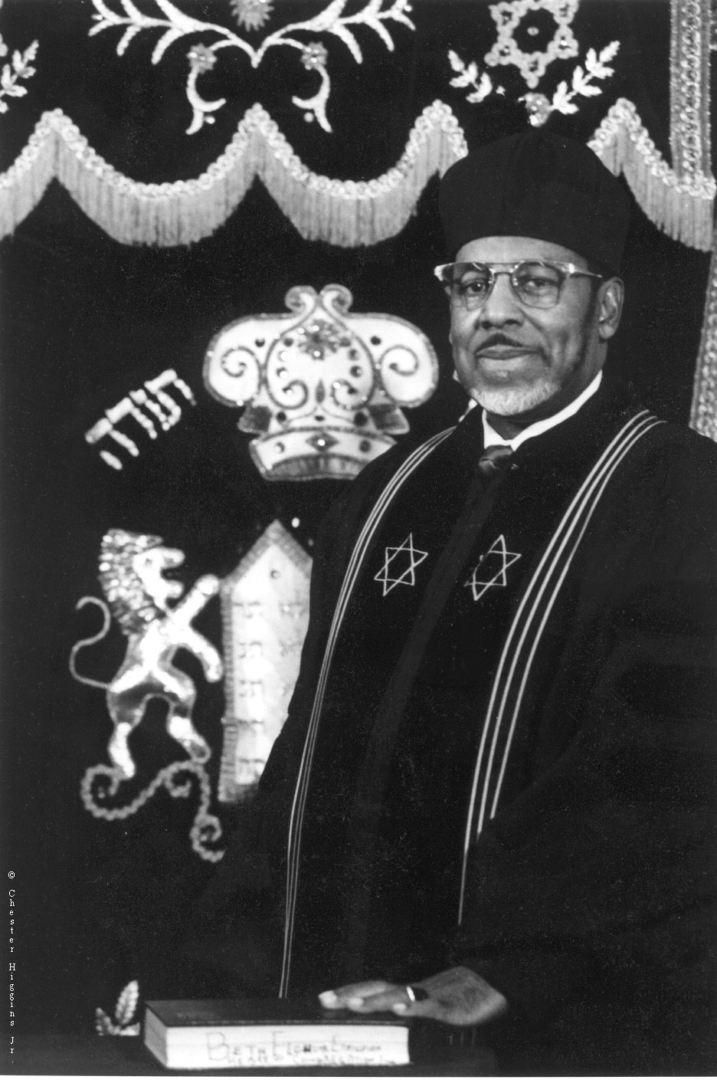
Rabbi Levi Ben Levy
1935-1999

Chief Rabbi Levi Ben Levy was one of the most dynamic black rabbis in America. He provided vital leadership for his people during the second half of the twentieth century as a teacher, speaker, community-organizer, founder of synagogues, and builder of organizations. Together with his many colleagues, he provided continuity with the past by preserving the work and memory of his teacher and our founder, Chief Rabbi W. A. Matthew. By combining vision with action, Chief Rabbi Levy helped to define who we were as a people and greatly influenced the direction of our progress. His accomplishments completed part of our foundation. Therefore, an understanding of his live is necessary to anyone who wants to know and appreciate our history.
This great leader was born on February 18, 1935 to a God-fearing family in Linden, North Carolina. It was there that he met and married his childhood sweetheart Deborah Byrd. In 1950, he came to New York City. After managing a restaurant and attempting a small business, the young Rabbi Levy enrolled at City College in 1957. He took courses at night while working for the Long Island Railroad to support his growing family. At this point, however, the hand of fate altered his path when his friend and coworker, Mr. Arnold Manot, invited him to attend the Commandment Keepers Congregation in Harlem, New York. It was there that he met the person who had the most profound affect on his life, Chief Rabbi Matthew. First, Rabbi Levy became a member of the congregation, then he was invited to joins its secret society called “The Royal Order of Ethiopian Hebrews Sons and Daughters of Culture.” After completing his Hebrew studies, his teachers and the mothers of the congregation, encouraged him to enter the Ethiopian Hebrew Rabbinical College in 1960. Through much hard work, sacrifices, and challenges he graduated six years later and was ordained by Chief Rabbi Matthew with great public acclaim in 1967.
Immediately upon graduation and ordination, Rabbi Levy knew that he was destined to do great things. He was trained and equipped with the truth to awaken the “lost House of Israel.” With Chief Rabbi Matthew’s blessing, Rabbi Levy started his first congregation, which he called Beth Shalom, in the living room of his Queens apartment with only eight members. For the first few years, as increasing numbers of people wanted to worship with them, they rented halls at various locations before acquiring their first building at 609 Marcy Avenue in Brooklyn, N.Y. In 1968, Rabbi Levy negotiated an arrangement with the Young Israel of Williamsburg that allowed him to move his congregation into the present home of Beth Shalom E. H. Congregation at 730 Willoughby Avenue.
In 1971, Rabbi Levy together with Rabbi Yisrael, Rabbi Yahonatan, Rabbi Woods, and Rabbi Paris—all students of Chief Rabbi Matthew—set out to revive their alma mater, the Ethiopian Hebrew Rabbinical College that was established in 1925. They expanded the curriculum and renamed their college The Israelite Rabbinical Academy. As other rabbis joined their ranks, and eager, dedicated men enrolled as students, a unified organizational body emerged which was first known as the Israelite Board of Rabbis and later, after establishing boards and chapters in other cities and then in Barbados, became the International Israelite Board of Rabbis. Four years after the death of Chief Rabbi Matthew in 1973, the rabbis of the International Israelite Board of Rabbis elected Rabbi Levy to be the next “Chief Rabbi.”
In 1983, Chief Rabbi Levy founded his second synagogue, Beth Elohim Hebrew Congregation, in Queens New York. In 1988, he installed his eldest son, Rabbi Sholomo Levy as the Spiritual Leader of the Congregation. Throughout the 1990s, Chief Rabbi Levy provided counsel and direction to those who sought his wisdom from his retirement home in North Carolina.
Amazingly, Chief Rabbi Levy managed to enjoy a full and wholesome family life despite his endless commitments and obligations. He and his wife, Deborah, were partners in love and life. Their marriage of over forty-six years produced six children: Deborah, Yehudith, Tamar, Zipporah, Sholomo, and Benyamin. At the time of his passing, he had nine grandchildren and many nieces, nephews, and God-children.
Chief Rabbi Levy gave honor to God and distinguished himself by founding two thriving congregations, Beth Shalom and Beth Elohim, an educational institution in the Israelite Rabbinical Academy that has produced most of the black rabbis in America, a unified leadership organization in the International Israelite Board of Rabbis, and gave us a quality publication in the The Hakol newsletter, and the first Israelite presence on the Internet. During his life, he received dozens of awards, plaques, and citations. He ran a half-hour radio program on radio station WWRL, he appeared on television programs such as “Black Pride,” and “Good Morning America” and he spoke to audiences internationally. For all these accomplishments and more, Chief Rabbi Levy is remembered as one of our greatest rabbis.
* No part of these essays may be used without the author’s permission.

List of Black Rabbis in America
Living Black Rabbis | Rabbis of Blessed Memory
Avraham Ben Israel | Abihu Ruben
Baruch Yehudah | Amasiah Yehudah
Benyamin B. Levy | Arnold J. Ford, First Rabbi
Bezallel Ben Yehudah | B. Alcids
Calib Yehoshua Levy | C. Harrel
Capers Funnye | C. Woods
D. Yachzeel | Chaim White
* Daton Nasi | Curtis Hinds
David Dore | D. Small
Eliezer Levi | David Levi
Eliyahu Yehudah | E. M. Gillard
Hailu Paris | E.J. Benson
* James Hodges | G. Marshall
Joshua Ben Yosef | H.S. Scott
K.Z. Yeshurun | James Bullins
Lehwi Yhoshua | James Y. Poinsett
Nathanyah Halevi | Jonah
Richard Nolan | Kadmiel Levi
Shelomi D. Levy | L. Samuel
Sholomo B. Levy | Lazarus
Yehoshua B. Yahonatan | Levi Ben Levy, Chief Rabbi
Yeshurun Eleazar | M. Thomas
Yeshurun Levy | Matthew. Stephens
Zacharia Ben Levi | Moses
Zakar Yeshurun | Patiel Evelyn
Zidkiyahu Levy | Raphael Tate
 | W. O. Young
 | Walcott
 | Wentworth A. Mathew, Founder
 | Yirmeyahu Ben Israel
* Rabbis who graduated from institutions other than the Israelite Rabbinical Academy
This list only covers members of the International Israelite Board of Rabbis

** Honorary Titles
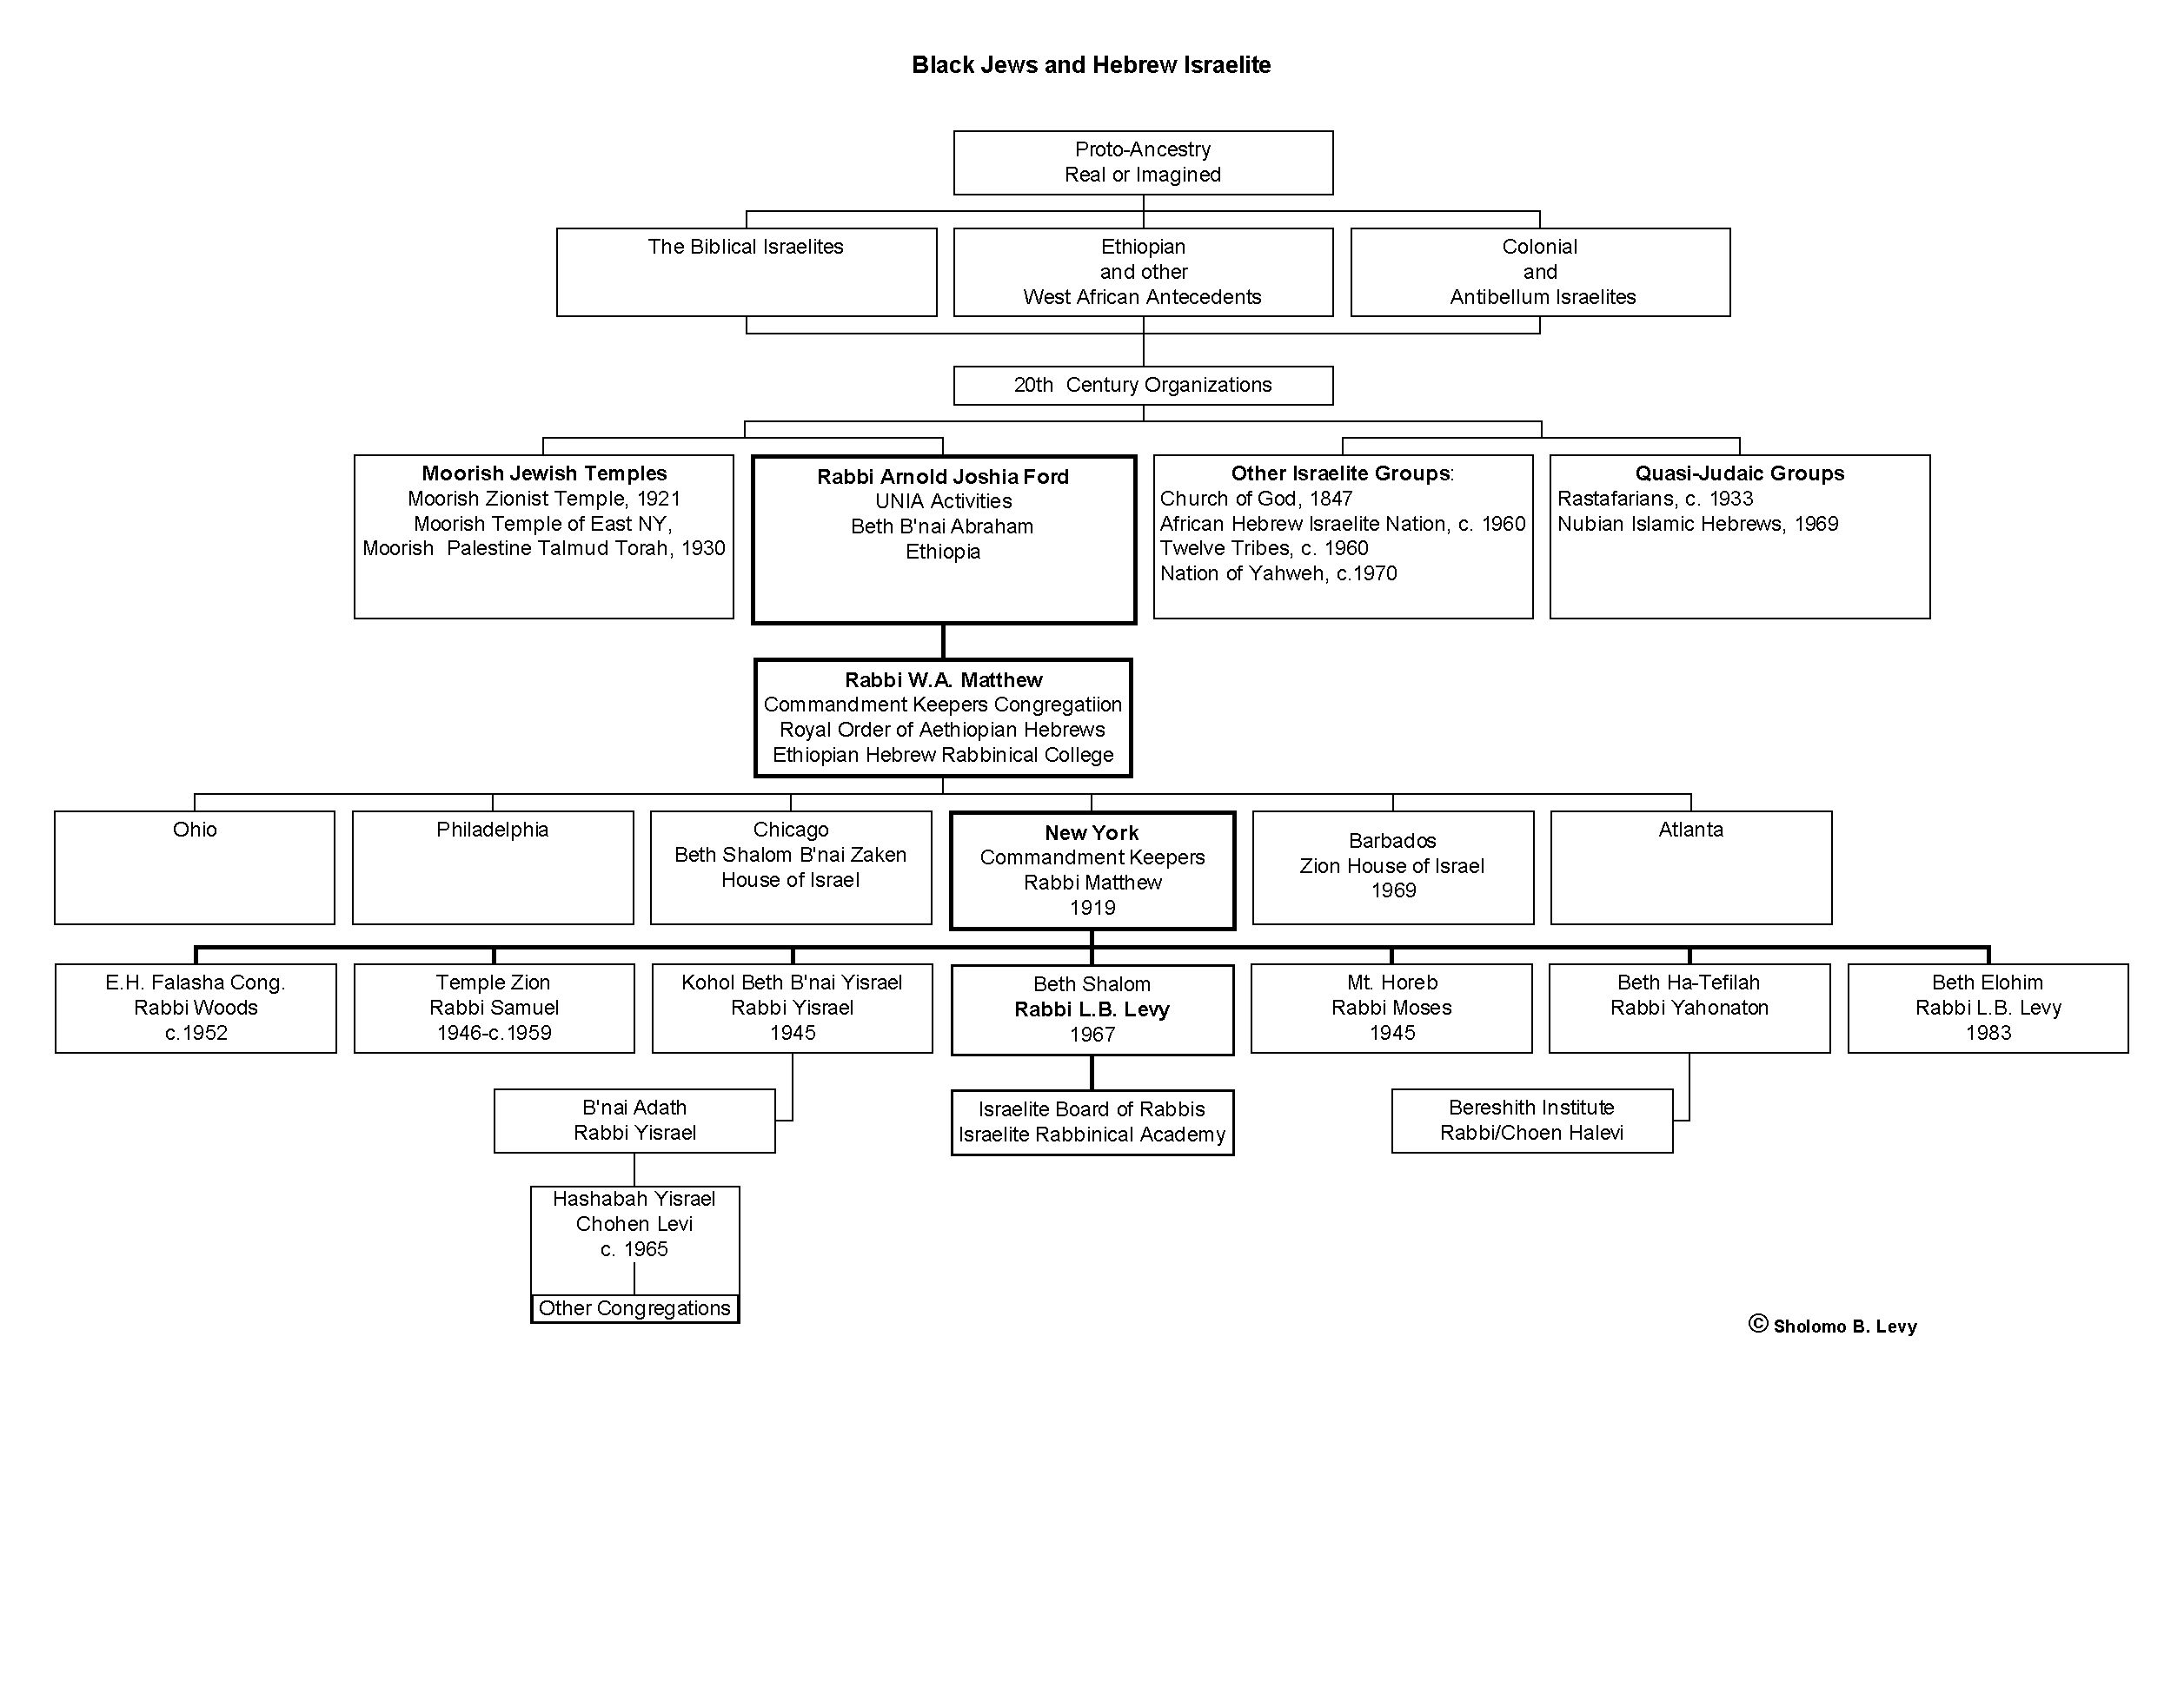
* No part of these essays may be used without the author’s permission.

This is a preliminary study. No part of it my be used or cited.
Yisroel and Yisrael are variant transliterations of the Hebrew word that is usually spelled Israel. The former spellings are more phonetically accurate and were the actual ones used
More information about Rabbi Rabbi Respes on this congregation can be found in the Schomburg clippings file on Black Jews and also in the following newspapers: New York Times 10 June 1973; 9 April 1978, and Washington Post, 2 March 1979.
Despite their reservations about white Jewish organizations, the record shows that on at least one occasion in February 1952 Kohol made a fifty dollar donation, a large sum given their means, to the United Jewish Appeal.
Rabbi Cadmiel Levy would lead Beth Av Shalom for a period of years in the 1980s.

