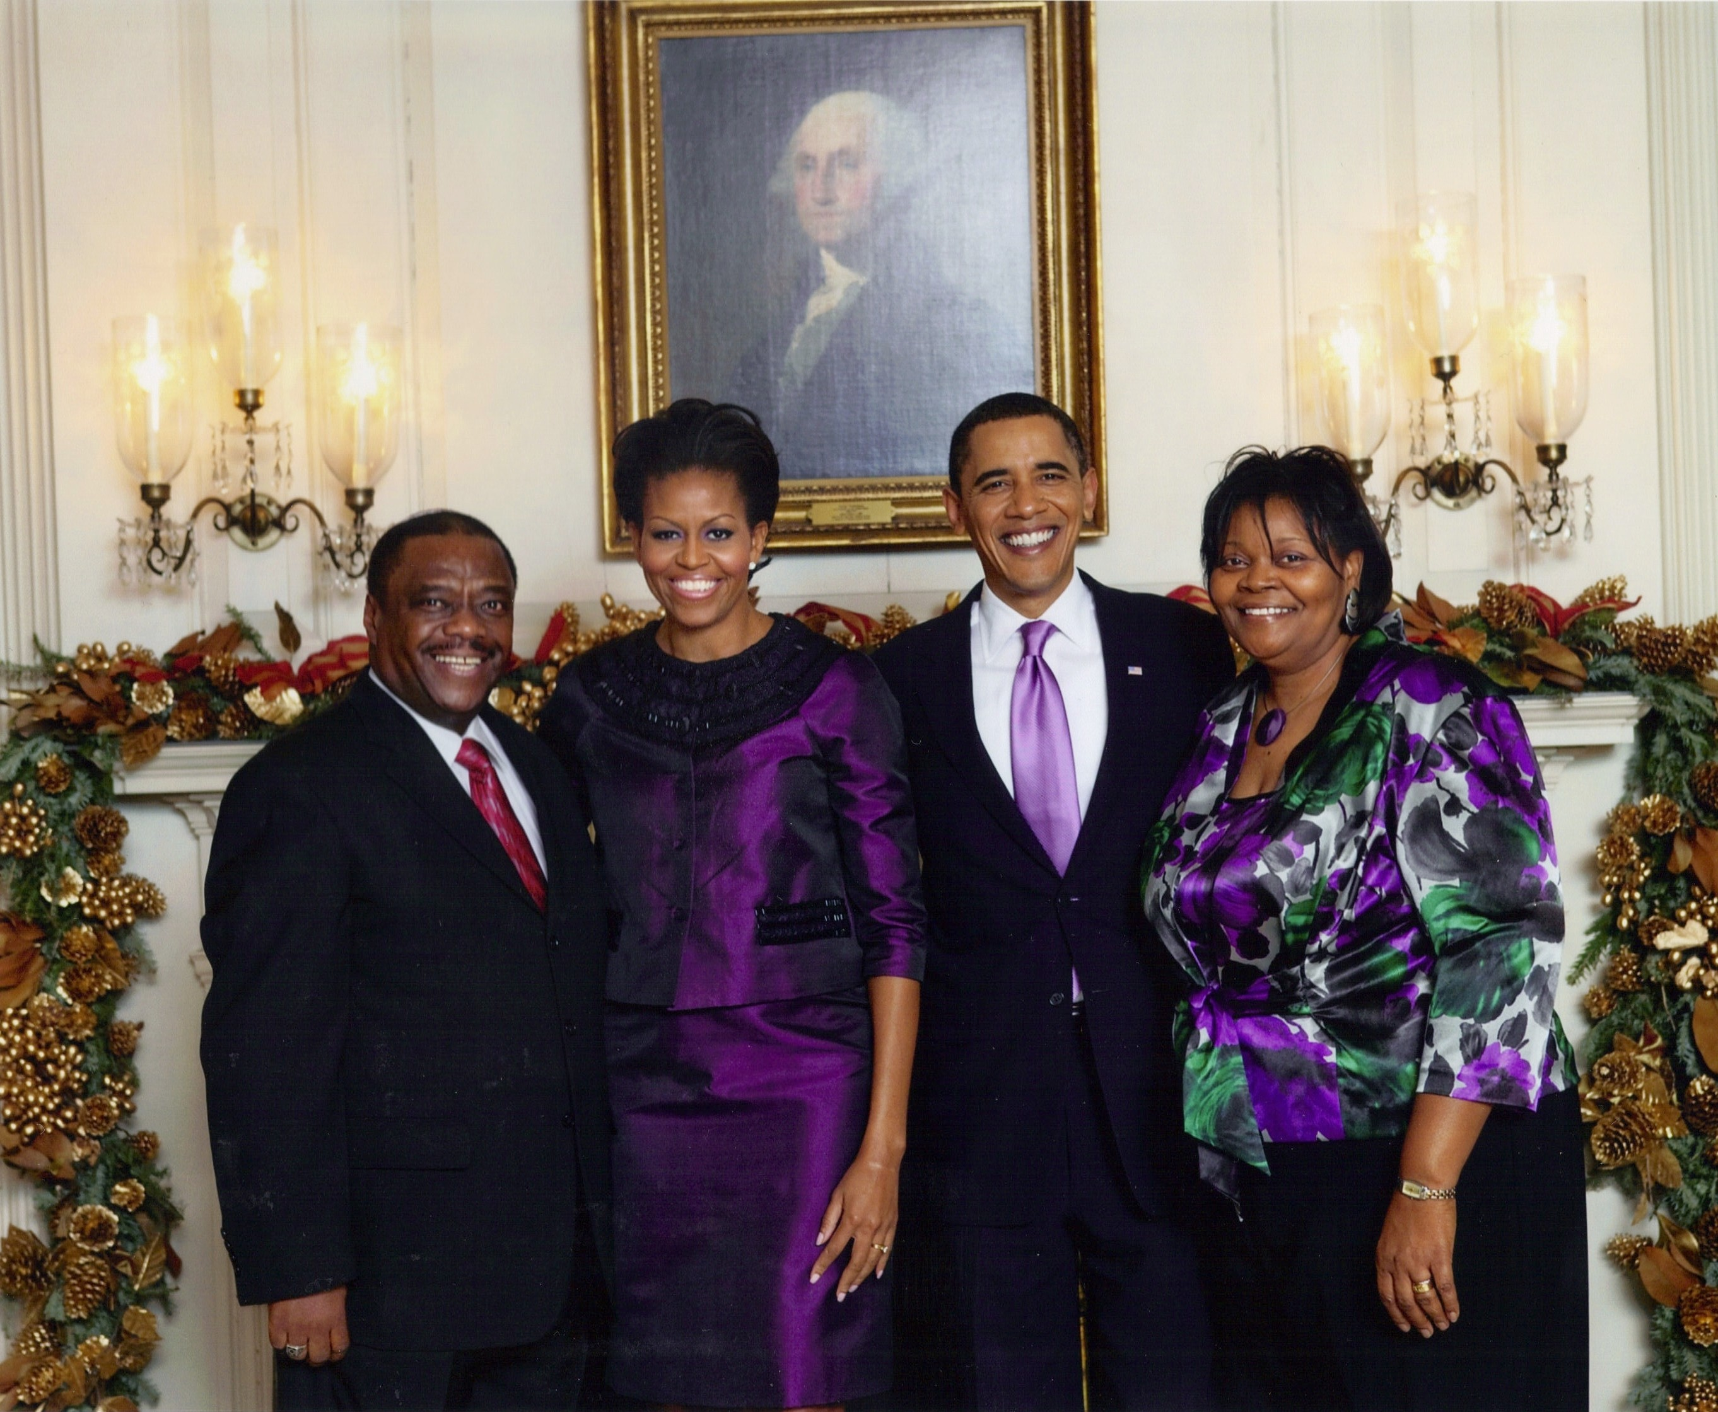
“The stone which the builders rejected is become the chief cornerstone. This is the LORD's doing; it is marvelous in our eyes.” Psalm 118:22-23 There was a time when Black Jews were not welcomed in the halls of power. Those days are gone forever! Today, Rabbi Shmuel Funnye travels the world meeting heads of state in Israel, Africa, and America. Most recently he and Miriam went to the Whitehouse to visit his cousin, Michelle, and her husband, Barack, for their Hanukkah Party. President Obama told the story of Hanukkah himself and explained to the assembled guests how much this celebration of freedom means to him. Rabbi Funnye, who attended a similar ceremony at the Whitehouse with President George W. Bush said the difference was “President Obama understands the Israelite Community because he has family members who are Black and Jewish. President Obama understands us because he understands the struggles of people who are marginalized because of their identity.”

Times are changing. Doors, minds, and hearts are opening. These things are happening because the promises of Hashem do not return empty (Isaiah 55:11). The African American poet Langston Hughes expressed the same sentiment in his poem “I, too, sing America” which has the hopeful lines: “Tomorrow,/ I’ll be at the table / When company comes. / Nobody’ll dare / Say to me, / “Eat in the kitchen,” Then. / Besides, / They’ll see how beautiful I am / And be ashamed--/ I, too, am America.” When I spoke to Rabbi Funnye about these changes he said that he is encouraged and optimistic about the future. The opportunities are there and increasing everyday. We must be prepared to accept them when available. A child who grew up rejected may as an adult expect rejection at every turn. Our community is mature enough to know that a lot has changed since 1919, thank God. Yet, there are still separatists who hide behind various theological and cultural guises to keep us apart. We understand the difference between unity and complete assimilation, between cooperation with people who accept us from seeking permission to be ourselves from people who deny us. Fortunately, no one is asking us to sell our birthright, like Esau, for a bowl of pottage. Instead, they are recognizing the value and beauty of our diversity. It is no longer seen as a weakness, but as one of our greatest strengths.

W.E.B. Du Boise explained the strange paradox of being Black in White America in his classic book Souls of Black Folk (1903). The similarity to being a Black Jew in a word that views Jews as White fits perfectly in this context. Du Boise acknowledged the tension that exists between these identities and the temptation to abandon one or the other in a vain quest for acceptance. Du Boise wrote that “He would not Africanize America, for America has too much to teach the world and Africa. He would not bleach his Negro soul in a flood of white Americanism, for he knows that Negro blood has a message for the world. He simply wishes to make it possible for a man to be both a Negro and an American without being cursed and spit upon by his fellow, without having the doors of Opportunity closed roughly in his face.” Likewise, we would not give up our Jewishness nor our Blackness. They are, in fact, inseparable parts of a single identity. We believe that we are blessed and enriched by this identity and it makes possible our contribution to the world.

As Rabbi Funnye travels to capitals, meets with heads of state, and dines with dignitaries around the world, he does so cognizant of the fact that he walks in the shoes of those who have gone before him. He stands on the shoulders of his teachers who believed this day would come. And, most importantly, Rabbi Funnye knows that he carries the dreams of our young and yet unborn. In a profound sense he carries all of us with him everywhere he goes, even to the Whitehouse. We, too, must understand that we are all ambassadors of the God we serve. The mission of our covenant is to be a גוים לאור “light unto the nations.” (Isaiah 42:6). Therefore, we must be proud of our collective progress as we work together and through our individual actions to continue this achievement.

Tuesday, March 2, 8:15 PM
92nd Street Y
1395 Lexington Ave., New York
$27. Use code BCHL for a 20% Be'chol Lashon discount!
Hear about Rabbi Funnye's journey to Judaism, his work with Be'chol Lashon to strengthen the global Jewish people, as well as a few inside stories about the First Family. Click here for tickets.
Rabbi Capers Funnye in Conversation with Ari L. Goldman

Rabbi Baruch
The memorial program for Chief Rabbi Levi Ben Levy was a tremendous success. Representatives from all the area congregations were present and Rabbi Debra Bowen came with a delegation from Philadelphia. The theme of the program was “The Musical Praise” of our late Chief Rabbi. This gave us an opportunity to examine the history, role, and influence of music on our practice of Judaism. The slide presentation carefully illustrated how our leaders, starting with Rabbi Arnold J. Ford, thought it vitally important that we preserve and integrate our musical traditions into our Judaic practices. Ford, Matthew, and Levy were all accomplished musicians as well as rabbis.

Our founders wisely separated two interrelated questions: (1) Who we are historically and theologically and (2) How we observe and express our beliefs. They observed that there were many Jewish communities around the world that shared the essential core beliefs, but yet maintained very distinct Jewish traditions. It was never their intention to make our community a clone of any other.

Shuvah (the process of returning to Judaism) is largely one by which people who have been called by God, return, and give all their praise, thanks, devotion, and obedience to the Creator alone. Our early leaders understood that many of our people who were coming out of darkness had to purge themselves of idolatry, free themselves of theologies that include the worship of a man as part of a trinity, and come into an understanding of the indivisible oneness of God. “Hear Oh Israel, the Lord our God, the Lord is One.” (Deut 6:4) This process did not require that we abandon the fervor, passion, power, and spiritual ecstasy that is possible through our cultural praise tradition.

How we praise Hashem comes out of our understanding of our Biblical tradition and our African heritage that we brought with us to our exile in Christianity. In other words, Christian missionaries did not teach their slaves to pray are we do. Slave maintained their praise tradition and misapplied it to Christianity. Now we are bringing it back to the worship of the Creator. People have said that our praise tradition resembles those of Black Christians. We believe the reverse is true: Black Christians have praise traditions that closely resemble those of the ancient Israelite. The Torah clears says, “And thou shalt love the LORD thy God with all thine heart, and with all thy soul, and with all thy might.” Deut 6:5. Sabbath morning prayers said in synagogues all over the world include the passage, “Praise him with the sound of the trumpet: praise him with the psaltery and harp. Praise him with the timbrel and dance: praise him with stringed instruments and organs. Praise him upon the loud cymbals: praise him upon the high sounding cymbals. Let every thing that hath breath praise the LORD. Praise ye the LORD.” Psalm 150:3-6. Yet, despite the fact that we all read this, few of us actually do it. Those who do might be accused of sounding like Black Christians. Furthermore, we have Biblical examples showing that David danced, Miriam played her tambourine, Moses sang, and Israel “cried” unto the Lord. Ironically, it was fear of ridicule by White Protestants that prompted White Jews to strip their services of many of our praise attributes. Of course, many of these traditions still find expression among Hassidic Jews who have, over the centuries, ignored criticism and pressure to conform to restrained expecations.

Rabbi Bowen’s brief remarks also focused on the musical theme of the day. She used several musical examples such as the Negro Spiritual “Go Down Moses” to demonstrate the deep affinity that our people have had with the Biblical Hebrews and Israelites. And, while we affirmed our cultural origins we also celebrated our embrace of certain European influences that are clearly seen in the structure of our liturgy, which is based on an Orthodox siddur, the prominence of many popular Jewish songs, our method of chanting or davenning, the presence of Hebrew, the calendar we follow, and mystical techniques designed to achieve a higher level of “kavannah” in prayer. We are proud and thankful for the ways in which we have incorporated these European customs into our current praise tradition. Therefore, our praise tradition is eclectic, but yet original.

Rabbi Baruch Yehudah, Dean of the Israelite Academy and a gifted vocalist himself, spoke about the origins and importance on this music to our way of life. He pointed out that we have never been merely consumers of these various traditions; instead, we have always been creators as well. He sung several examples of songs composed by Cohen Levi. One was an Israelite rendition of the 150th Psalm in Hebrew. The other was a deeply moving piece called “What’s My Name? (see YouTube Video) In Rabbi Baruch one not only sees the importance of music, but also dress as integral parts of our cultural identity.

Throughout the program there were musical selection by Mother Tariah (sp) and a mini concert by the Beth Elohim Choir. Plaques in memory of Rabbi Yahonatan and Asher Ben Yehudah were unveiled on our Tree of Life. Yizkor prayers were made for all of our departed leaders. CD’s and DVD’s of this event are available for purchase.

Economic Summit # 2
On behalf of the International Israelite Board of Rabbis, Inc. This is a brief communication to let you know we appreciate you and we are encouraged that you take to the time from your busy schedules to sit at the table at the 1st Israelite Economic Summit and show UNITY to the community that we are serious about our economic future as a community and have a plan of action to strengthen our nation.
This years panelists consist of our spiritual leaders in the community, professionals, business owners and we are pleased to have the NYC - consumer affairs OFE co-sponsor this event once again.
We are all in this together, so lets come together and solve the problems in our community together.

It is the responsibility of each member to make the most of his or her life, and it is the responsibility of the larger community to provide the conditions that encourage success - a healthy, stable environment and opportunities for educational and economic achievement. As a prelude to the summit, I want to share with you some community observations and offer some solutions to change our situation for the better:

Our Greatest Strengths
- We are morally grounded and spiritually rooted. Instincitively we have faith and hope in a brighter day.
- We are creative, and very talented in just about every area you can think of.
- We persevere, having common sense, street smarts, mother wit, and a strong sense of survival.
- We are loyal to those who sincerely reach out out to us and We are forgiving of those who have hurt us the most.
Our Weaknesses

- We tend to distrust each other, due to the long history of tactics used to divide and conquer us.
- As a whole, we tend to have low self-esteem and pride, due to hundreds of years of negative reinforcement.
- We shy away from risk, choosing instead to safely conserve and protect the material resources we worked hard to acquire.
Ten Inportant changes / Solutions
- We must see hard work in all things not as a necessary evil but as a way to escape poverty and as a wish of the Almighty.
- We must have an attitude toward all work that insists on precision and attention to detail. In other words, high personal achievement is the goal.
- We must see high educational achievement as something that is greatly valued; therefore we must push ourselves and our children.
- We must be committed to lifelong learning and see learning from others as a way to build cooperation and partnerships.
- We must now focus on wealth and job creation by leveraging our Yah-given strengths to overcome our weaknesses.
- We must see saving and investing as a commitment to future generational prosperity.
- We must support our own businesses first.
- We must have a bottom-up (community-based) approach to problem -solving, instead of a top-down approach.
- Each must take personal responsibility and have a positive attitude toward solving our problems to facilitate change.
- We must hold to the moral path and refuse to participate in the generalized decay in values in business, family, and community.
Lastly, the Torah commands us to Love each other and to care for each other. Let us stay focused as to what our purpose as a nation is and why we are here in this land. So, with the Help of the Holy-One, we will rise to the challenge and govern ourselves with Integrity, Wisdom, Excellence, Holiness, Love and Righteousness. Baruch Shem Kevod Makuto LeOlam vaed!.
Sunday, March 14, 2010
Beth Elohim
12:00-3:00

Torah Blessings,your servant R'Benyamin Levy, NYIBR, President
189-31 Linden Blvd, St Albans, NY 11412
718-712-4646 or 718-216-1429
www.blackjews.org

Passover Announcement

